**Report on the Painting Competition and Health & Hygiene Survey at T. Hosahalli**

**1. Introduction**

On the occasion of the upcoming Independence Day celebrations, a painting competition was organized at the Government Middle School in T. Hosahalli. The event was designed to foster creativity and unity among students, with the theme "Colors of India" reflecting the rich diversity and culture of the nation. In addition to the competition, a health and hygiene survey was conducted in the village to assess the well-being of the community.

**2. Painting Competition: "Colors of India"**

* **Participants:**
  + Students from the Government Middle School in T. Hosahalli.
  + Students from the Design School.
* **Objective:**
  + To encourage collaboration between local students and those from the Design School.
  + To promote artistic expression and awareness of India's cultural heritage.
* **Theme:**
  + "Colors of India" was chosen to allow students to explore and depict the vibrant traditions, festivals, landscapes, and diversity of India.
* **Collaboration:**
  + Students from both institutions worked together in teams, sharing ideas and techniques to create their paintings.
* **Awards:**
  + Winning students were recognized for their creativity and teamwork. The awards included:
    - **Moral Storybooks** to promote ethical values.
    - **English Copywriting Books** to enhance their language skills.
    - **Certificates** of achievement to encourage their participation in future events.

**3. Health and Hygiene Survey**

* **Purpose:**
  + To assess the health and hygiene practices of the residents of T. Hosahalli and identify areas for improvement.
* **Methodology:**
  + A team conducted door-to-door surveys, interviewing residents about their daily health practices, access to clean water, sanitation facilities, and awareness of hygiene practices.
* **Findings:**
  + Preliminary results indicated that while some residents had access to basic sanitation, there were areas where improvements could be made, particularly in waste management and awareness of hygiene practices.
* **Recommendations:**
  + Organize workshops on health and hygiene to educate residents on best practices.

Collaborate with local authorities to improve access to clean water and sanitation facilities

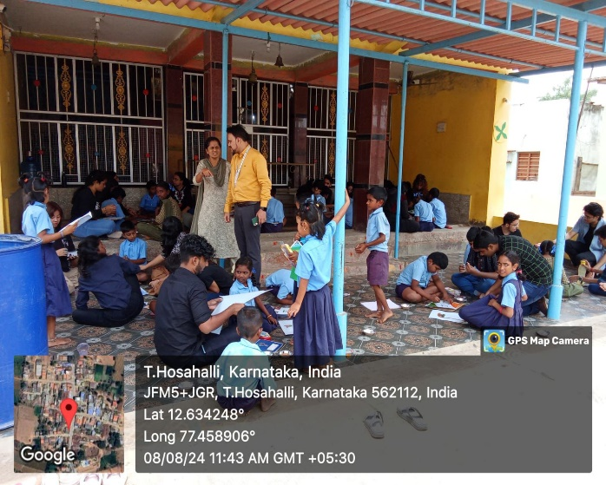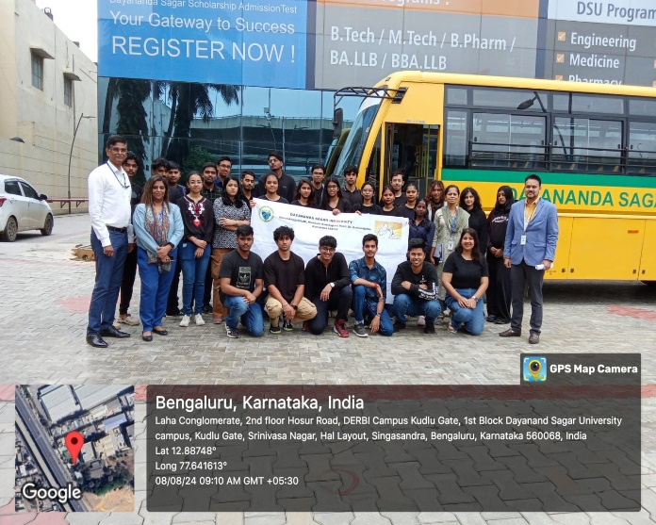

**4. Conclusion**

The painting competition at the Government Middle School in T. Hosahalli was a successful event that brought together students from different backgrounds, fostering creativity and unity. The health and hygiene survey provided valuable insights into the well-being of the village residents, paving the way for future initiatives to improve their quality of life. Both activities were well-received and contributed to the overall spirit of community engagement and national pride in the lead-up to Independence Day